Elements, Compounds & Mixtures

Element names and symbols:
1) | 6)
2) | 7)
3) | 8)
4) | 9)
5) | 10)

Define the term element:

Particle diagrams for a solid, liquid and gaseous element:

Define the term compound:

What does the formula H₂O mean?

Define the term molecule:

Particle diagrams for H₂O in the solid, liquid and gaseous states:

Fill in the blanks
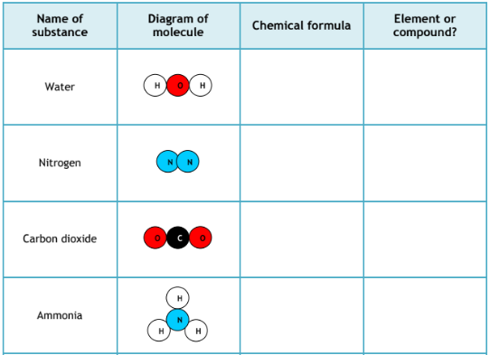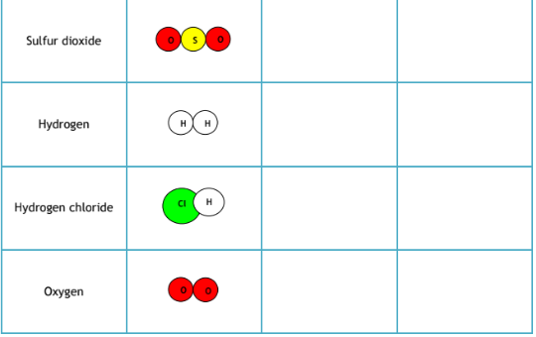

Questions about elements and compounds
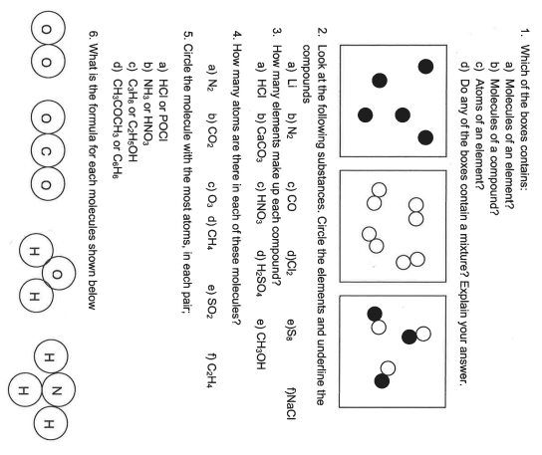
Define the term mixture?

Draw three particle diagrams to show the following:

A solid mixture  (e.g. a metal alloy) |  | A ‘liquid’ mixture  (e.g. seawater) |  | A gas mixture  (e.g. air)

